St. Johns Lutheran Church

3738 Morgan Ford Rd.

St. Louis, MO 63116

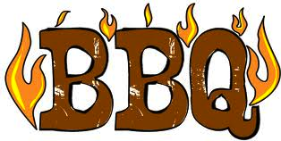

Saturday, April 2, 2016
11:00 AM to 4:00 PM

Menu will include

1 Piece Hot Dog Sandwich $3.00
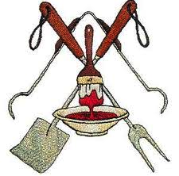1 Piece Bratwurst Sandwich $3.50
2 Piece Bratwurst Dinner $7.00
½ Pork Steak Sandwich $5.50
Pork Steak Dinner $8.50
¼ Chicken Sandwich $5.50
½ Chicken Dinner $8.50
½ Rack of Ribs Dinner $10. 00
Rack of Ribs Dinner $19.00

Dinners Include Dessert, Bread and a choice of two sides
(Potato Salad, Slaw or Beans).

Delivery Available For Four Or More Orders

Any questions or Advance orders call Eunice @314 306-0763 or the church office.

Email orders to stjohnslcstl@gmail.com by March 30, 2016 or

To order on the day of the barbecue call (314) 773-0126

If you would like to have future BBQ announcements emailed to you please provide your email address here _________________ or email to stjohnslcstl@gmail.com.

Sponsored by the members of St. Johns Lutheran Church Ushers.

